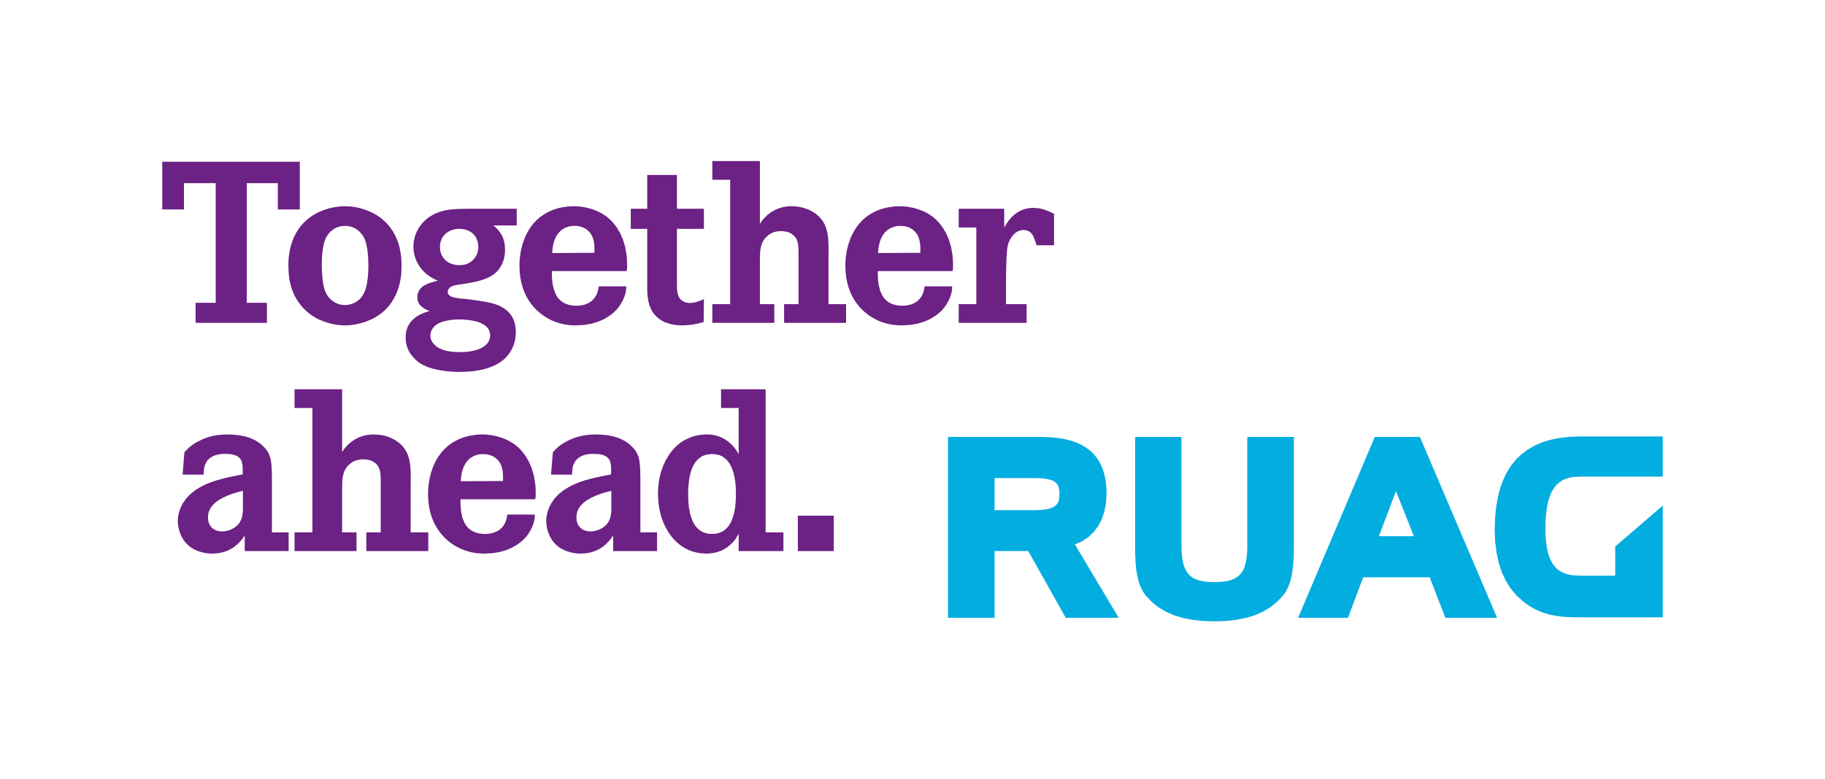

RUAG International Holding Ltd.  
Bahnhofplatz 10b  
3011 Bern  
Switzerland  
[www.ruag.com](http://www.ruag.com)

Zürich, 28.06.2024

**DDTrO-Statement 2023 | RUAG International**

Respecting and protecting human rights is an essential part of RUAG International's corporate responsibility when procuring goods and services. Therefore, RUAG International focuses on core human rights risks with a high probability of occurrence and a potentially significant impact on those affected and local communities. Due diligence obligations regarding human rights and child labour in particular have always been part of supplier management at RUAG International. The management approach includes a Code of Conduct for suppliers,which forms an integral part of the supplier contracts. Violations of the Code of Conduct are sanctioned, whereby sanctions can go as far as terminating the business relationship.

This report relates to the due diligence and reporting obligations required by Art. 964j-k CO and the Ordinance on Due Diligence and Transparency in Relation to Minerals and Metals from Conflict-Affected Areas and Child Labour (DDTrO). It covers the period January 1st  2023, to December 31st 2023. During the reported period, RUAG International complied with the due diligence obligations regarding child labour, as further detailed below. For minerals and metals from conflict affected areas, RUAG International assumes that it did not import such minerals and metals in the reporting year, or did not import them in legally relevant quantities, which is why there is no reporting obligation of RUAG International.

To adhere to its specific due diligence obligations according to the DDTrO, RUAG International has completed a risk assessment of its supply chain using the "UNICEF children's right in the workplace index" as benchmark. The initial risk assesment showed that RUAG International sources materials /assemblies and services in diverse quantities from 178 suppliers from critical countries (classification: "heightened") or from countries with an increased risk for child labour ("enhanced"). Based on the results of the risk assessment RUAG International engaged with the 178 suppliers to gain information on how these suppliers are taking action to address child labour risks and impacts in their own operations and supply chain and whether the suppliers are aware of child labour cases in their operations. The self-declarations and reports handed in by the suppliers were reviewed and checked for plausibility with publicly available information by RUAG International and have not given rise to any suspicion of child labour in RUAG International’s supply chain.

Furthermore, employees and third-parties worldwide were able to utilize RUAG International’s whistleblowing system either [online](https://beyondgravity.speakup.report/beyondgravity) or by phone (see [here](https://www.ruag.com/system/files/media_document/2023-12/phonenumbers_speakup_basic.pdf) for local phone numbers)  if they suspected or observed irregularities or violations. The system allows anonymous incident reporting and confidentiality within RUAG International’s Compliance & Governance department. In the relevant period no incidents related to child labour were reported over the whistleblowing systems.

**Board of Directors of RUAG International**

© RUAG International Holding Ltd., 2024 1 | 1